To Date: 06/09/2023

The Academic Section,

Delhi Technological University,

Delhi, 110042

Subject: Request to handover my provisional degree and 8th Semester marksheet to Dhruv Singh (2K20/EE/93).

Respected Sir/Madam,

I, Shivam Kumar (2K19/IT/118), student of the Information Technology branch of the 2019 batch is unable to come to the college to collect my provisional degree and 8th semester marksheet because of being working in bangalore and not having leave.

I request you to provide my provisional degree and 8th semester marksheet to Dhruv Singh (2K20/EE/93) as I need it to submit to my office.

Thanking You,

Yours Sincerely

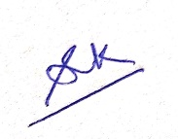

Shivam Kumar